At Fairview Cleaners we have a trained experienced team regarding fabric technology. We are passionate about selecting the best treatment, cleaning, hand finishing process to help revitalise and retexture valued garments. We care about each item we clean, how we treat and look after all customer garments. We work with the guidelines of guild of cleaners and launderers to ensure we are handling items with the best process and cleaning practices alongside the label aftercare guidance.
Unfortunately, some things are outside our control and some leading brands still have aftercare cleaning problems with their fabric/s, the materials used in the manufacturing process, the colour dyes used or finishing treatments. While there may be guidance or pictograms on the aftercare label not all items have been laboratory tested or meet the appropriate BSI / ISO standards. We understand that over time garments show a little wear with use, so we may also highlight a stain/mark, missing buttons/ fasteners, loss of colour, or fabric fibre damage that may affect the hand finishing and appearance of the garment.
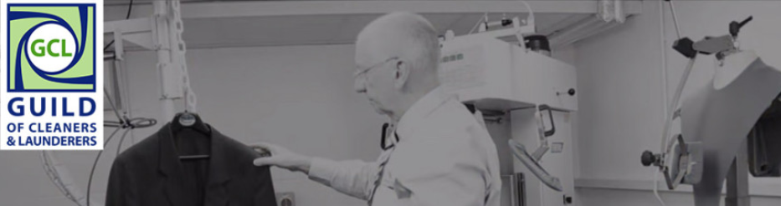
We pride on being the best at caring for the things that you enjoy and love. That’s why we want you to make the decision on to proceed with the risk of cleaning, if we are uncertain on the finished appearance and we never what to hand finish an item which is below your expectations or our high standards.
We would want to bring to your attention one or more of the following points;
- The item has no reliable aftercare information labelled or it is unlikely to have been tested to relevant BSI / ISO standards and the fabric could be damage or experience colour transfers
- There are marks or stains which may affect the finished appearance
- The fabric or stitching has some abrasion, tears, rips, splits
- There may be some de-lamination, shrinkage or interlinings issues with the type of fabric/s
- The care process to clean the item may be of detriment to the fibric appearance, colour or shape
- There may be buttons, fasteners, beading missing or damaged
We will verbally confirm what our concerns are and will give you a copy of this notice or show you the online version as acknowledgement of the advice. The notice and disclaimer will need to be acknowledged prior to the cleaning process.
Disclaimer Notice: Fairview Cleaners does not guarantee or accept any liability should the garment fail in any of the above points and you accept that this notice as a waiver of your statutory rights, this waiver will only operate in relation to the garment discussed or mentioned in correspondences.
Typical Cleaning Symbols:
